**Response to the editor and reviewer**

We greatly appreciate the editor and the reviewer for the efforts and the valuable suggestions and hope that deficiencies pointed out in the original submission are overcome in the revised version. Our responses of the Referee’s Report are given below.

--------------------------------------------------

**General comments**

*Some remaining typos*

*p11, l60 don't change -> doesn't change*

*p14, l37 cateogry -> category*

*Table 2 simualted -> simulated*

*Table 4, figure 14 senario -> scenario*

**Author’s Response:**

Thank you very much for pointing out the typos.

In the latest manuscript, the mistakes have been corrected.

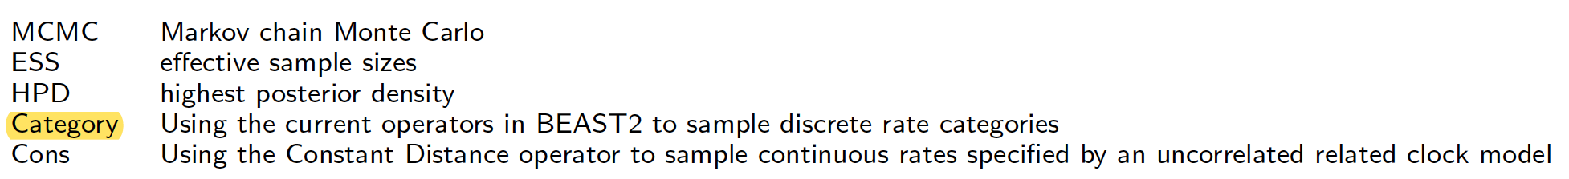

**We greatly appreciate the reviewer for the valuable suggestions. We try our best to overcome the deficiencies pointed out in the original submission. If there are any problems in the revised version, please do not hesitate to point out. We will revise the submission according to reviewer’s suggestions.**